Test Case: runTestMultipleTimes
Step 1 - Enter username and password and click to button Enter : Credentials Entered
Image file-name: QC_Testing-runTestMultipleTimes-nov. 20 2025, 05 49 27 p. m.

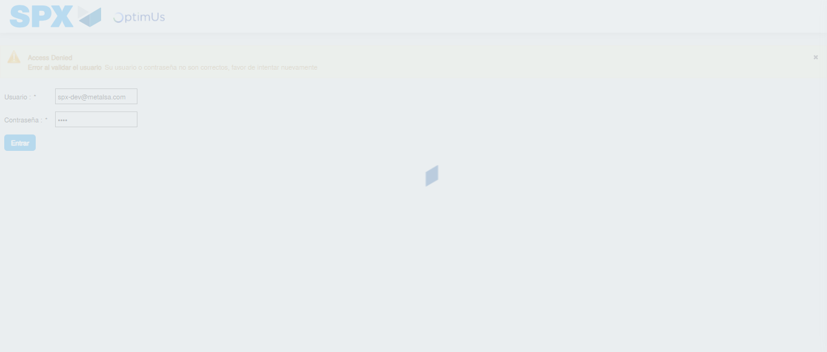Image file-name: QC_Testing-runTestMultipleTimes-nov. 20 2025, 05 49 28 p. m.

Step 2 - Select to UEN and Access to Administrador Roles Menu: UEN Correctly selected and Correct access
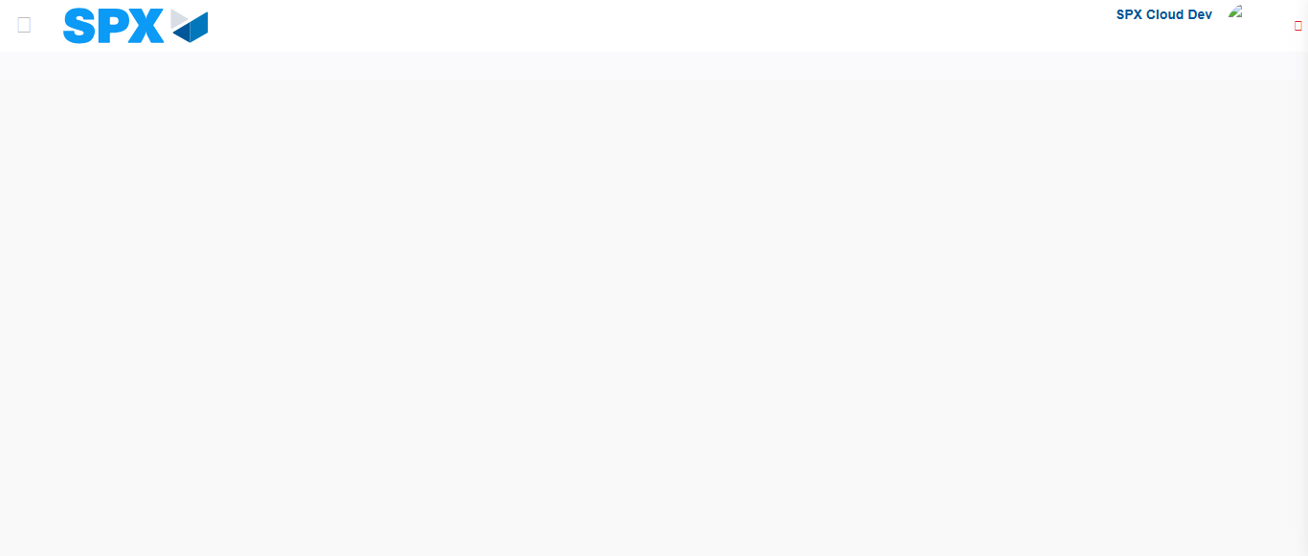Image file-name: QC_Testing-runTestMultipleTimes-nov. 20 2025, 05 49 38 p. m.

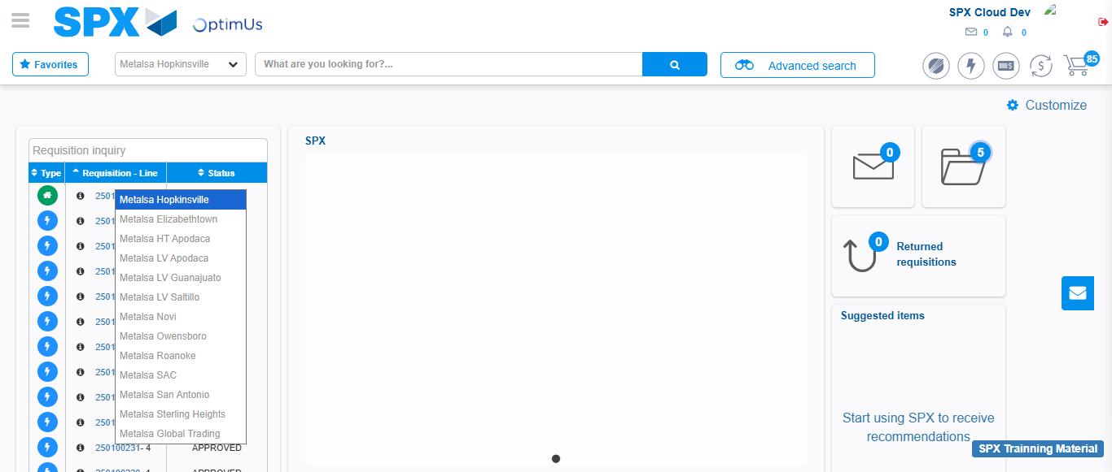Image file-name: QC_Testing-runTestMultipleTimes-nov. 20 2025, 05 49 39 p. m.

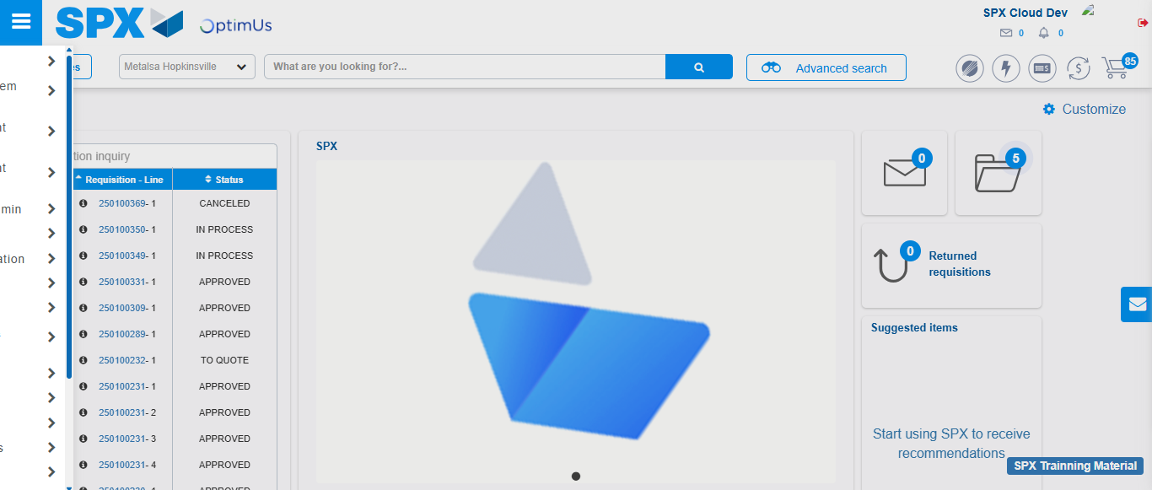Image file-name: QC_Testing-runTestMultipleTimes-nov. 20 2025, 05 49 50 p. m.

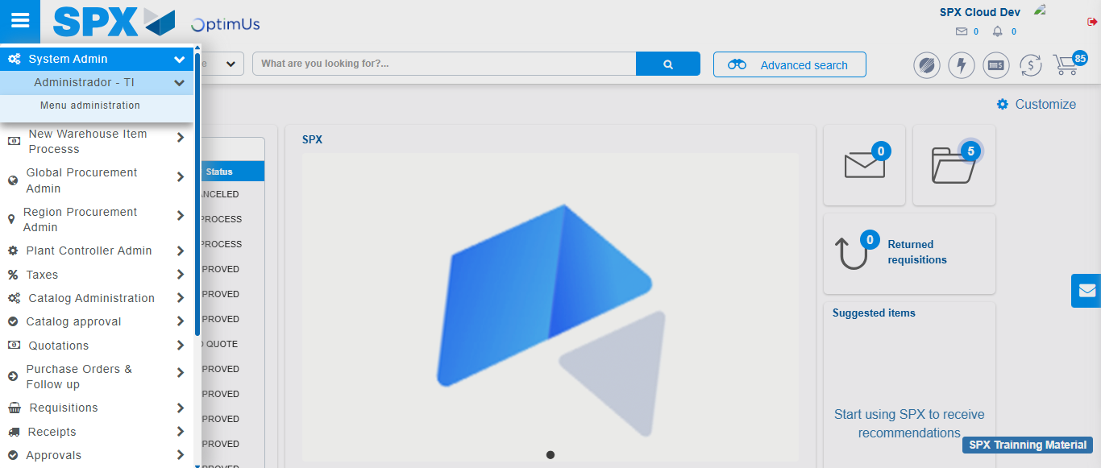Image file-name: QC_Testing-runTestMultipleTimes-nov. 20 2025, 05 49 51 p. m.

Image file-name: QC_Testing-runTestMultipleTimes-nov. 20 2025, 05 49 54 p. m.

Step 3 - Click to Buttons View Menu and Search Filter with Menu Name: Correct Search
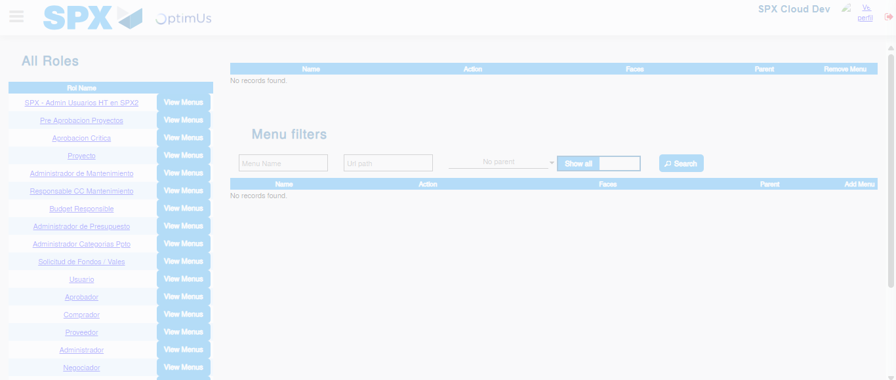Image file-name: QC_Testing-runTestMultipleTimes-nov. 20 2025, 05 49 55 p. m.

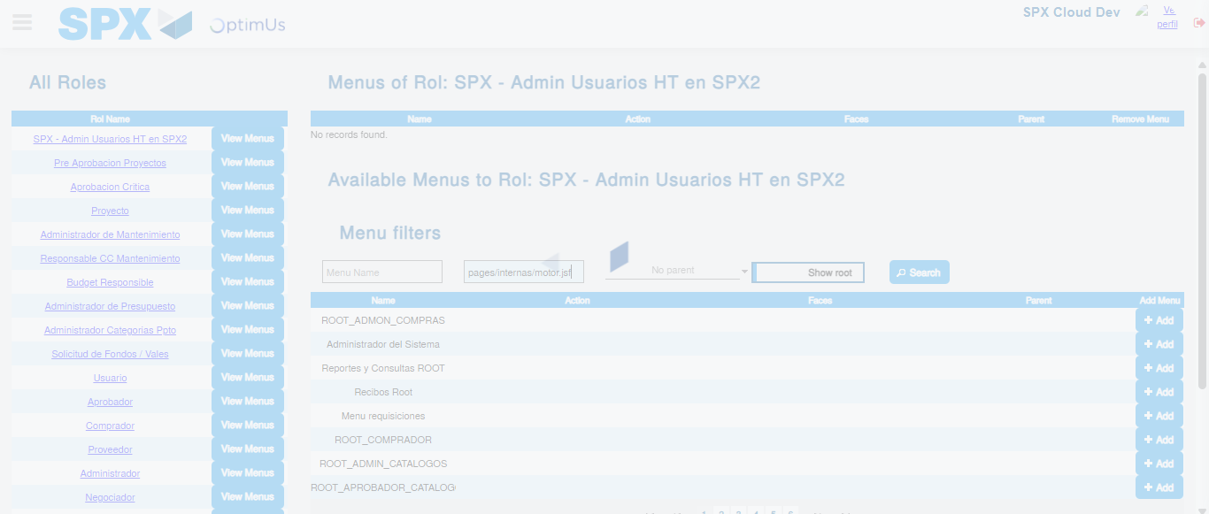Image file-name: QC_Testing-runTestMultipleTimes-nov. 20 2025, 05 49 56 p. m.

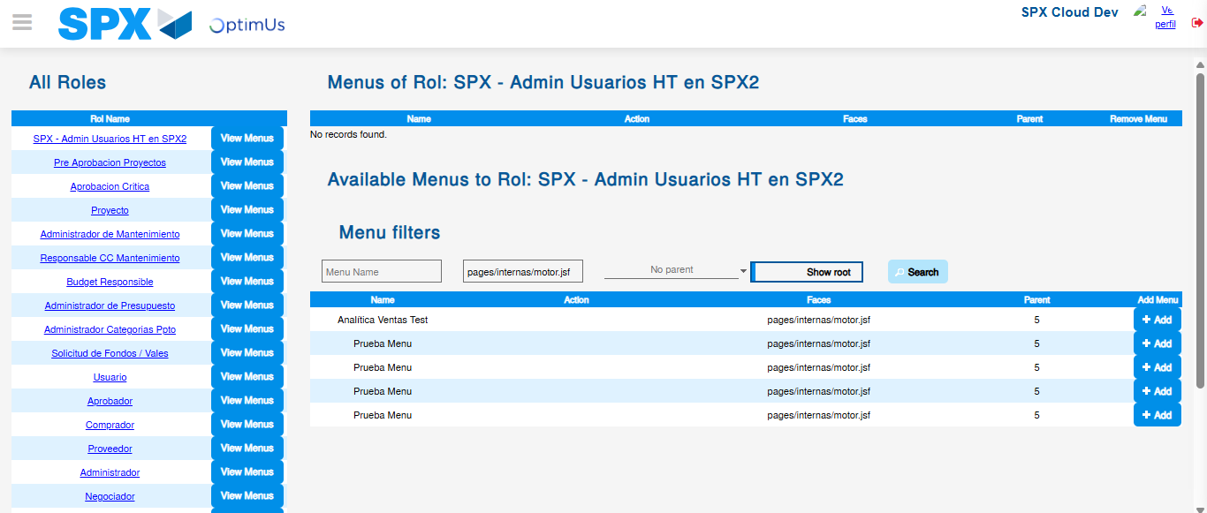Image file-name: QC_Testing-runTestMultipleTimes-nov. 20 2025, 05 49 57 p. m.

